SSHI Report: 3/6/20

* Status of 1-year extension
* MOU with Anacua Farms
* Potential partnership with Jacob Pekar: <https://www.texasagriscience.com/contact-us>
  + Sunnhemp seed varietal trial

Hilltop Gardens

Block 15:

* Rod weeded last week of March 9 to terminate existing daikon radish, but had some mechanical issues with the dry chain
  + In progress
* Lack of moisture is significant enough to prevent planting sorghum
  + >12% at 8” depth
* Field work on standby due to COVID-19
  + Hilltop Gardens closed to public for the next 2 weeks
* April 15th is the deadline for planting sorghum (1 month remaining)
  + More risk for pest infestations
  + Need to weigh the costs vs benefits of planting this year
* Dry winter, dry spring – difficult time for everyone in dryland farming

Block 17, 18, 19:

* 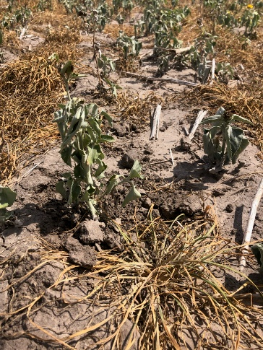Run disk over cereal rye and black oats
  + - * + Lack of moisture
* Iron & Clay cowpea seed and inoculum arrived
* Block 19 will disk and wait two weeks to plant the cowpea and sudangrass mix due to cereal rye’s allelopathic properties

Cereal rye in block 19