Weekly Report 2/28/2020
Hilltop:
Block 17 & 18: Black Oats
- Black oats undergoing leaf senescence
- Plant Cowpea & Sorghum Sudangrass directly into residue to avoid disking
  - w/ the exception of block 18 where there is high cattail population
- No official termination or planting date yet
Block 19:
- Captured drone images on 2/24 & 2/28 w/ Israel Galindo from SARA
- No official termination date – will wait 10 days to plants Cowpea/Sudangrass mix
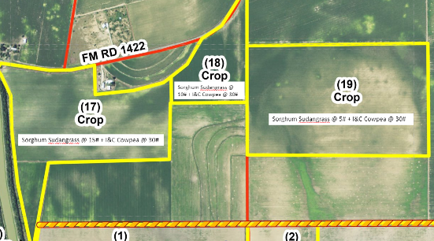
Spring Plans:
- Order I&C seed ASAP
- Sudangrass seed purchased
- Selected option #1 for simplicity sake
Block 15: Cover Crop Mix Species Trial
- Short 5# of sorghum grain seed – Andy planting 10 acres instead of 12 – covering rest of 2 acres in leftover cover crop seed
- Removed moisture sensors on 2/24/20 with Matt Kutugata and Fallon Faustro
Sunnhemp seed and termination varietal trials status:
- Single variety termination study
  - Move to 1 location @ Anacua Farms ‘Middle Meade’
    - 75 acres x 5 termination treatment sweep plow, flail mow, sickle bar mow, sweep plow with crimper, and weed zapper
    - Divide field further by 2 to compare difference timing of termination
- Reduced trial size for seed production
- 1) 5# of Tropic Sunn from Plant Materials Lab; 2) Hawaii & 1-2# of AU Golden Seed; 3) 5# saved SH seed from Hunter’s farm
  - Small scale trials @ UTRGV Research Garden
  - Triphenyl Tetrazolium Chloride (TTC) viability test after seed harvest

