SSHI Report 2/21/20
Block 15: Mix Species Cover Crop Trials
- 7 weeks since terminating cover crops
- Average soil moisture for block 15 is around 6-7%
- Received 0.043” of rain this week
- Matthew, Lindsey and Fallon uninstalling moisture sensors on Monday so Andy can plant sorghum as soon as he’s ready

Block 19: Cereal Rye Varietal Trial
- Collecting drone imagery next week
- Izzy from SARA is helping us with video w/ brief commentary about results
- Good weed suppression overall

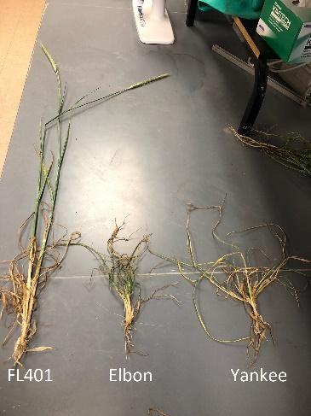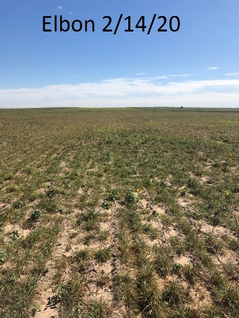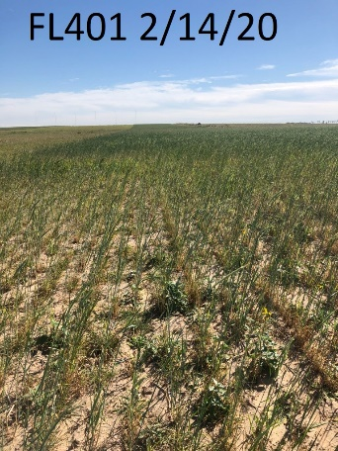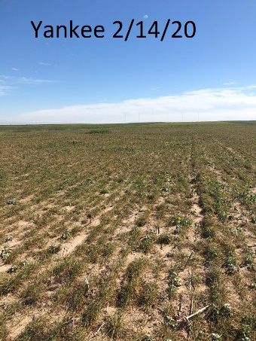

Block 17 & 18: Black Oats
- Need to renew device subscription for moisture sensors – in progress

