SSHI Report 11/8/19
Hilltop:
- Planted block 19 in three different varieties of cereal rye (Yankee, Elbon, and FL401)
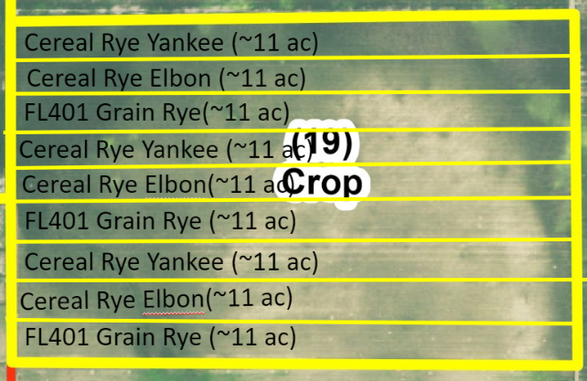
  - 3 reps of ea.; 11-acre strips
Block 15
- Measured respiration on 11/6 – Dr. Hannah Penn and Dr. Robin Chowdry tagged along. Dr. Penn used matts drone imagery to locate harvest ant colonies and ground truth their locations. She is interested in how ant colonies are distributed based on soil type and soil moisture. Dr. Chowdry was assisting Dr. Penn and gathering plant samples to gather preliminary data on cowpea diseases.
- Total rainfall as of Oct. 1 through Nov. 8 = 29.748 mm (1.17”) (data pg 2)

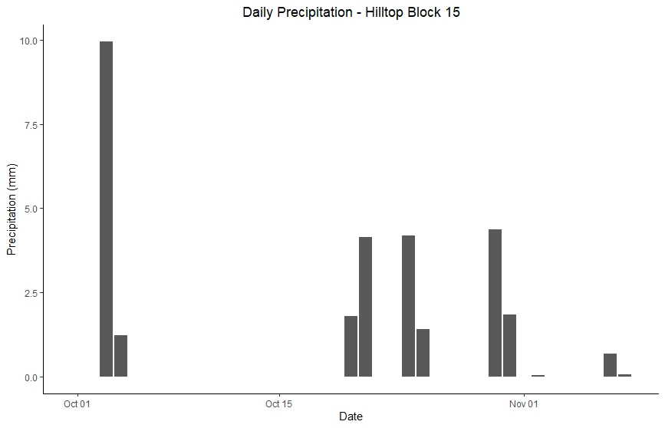
Precipitation data from the ATMOS 41 weather station

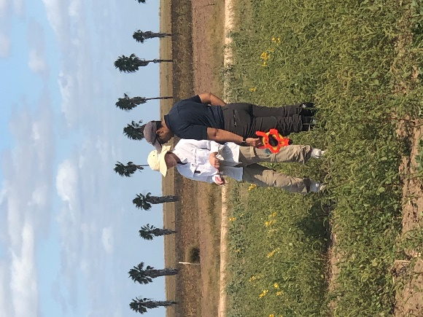
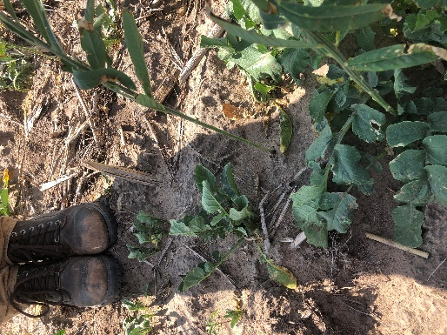
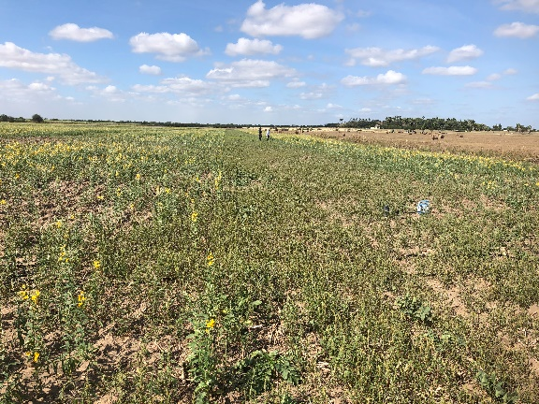
Dr. Penn & Dr. Chowdry observing harvester ant colonies

Field condition (Rep 1,2 & 3 from right to left)

Mustard and Radish

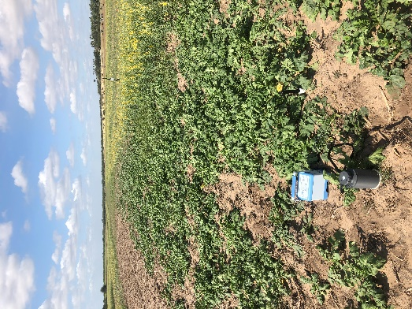
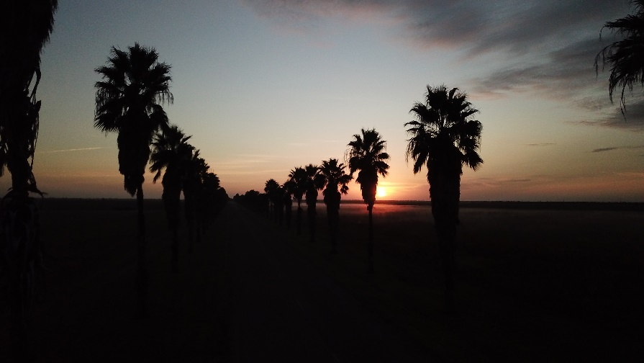

Hilltop in the morning. Photo cred: Isreal Galindo

Radish/Black Oats/Vetch Mix

