SSHI Report 10/17/19
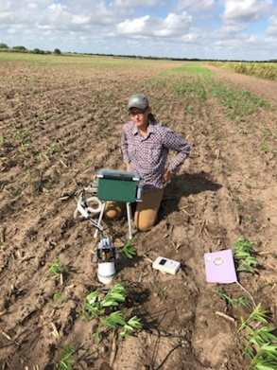
Hilltop:
- Seeds arrived for blocks 17, 18, and 19
  - ~30# damaged seed from Handcock and unknown amount damaged from Petcher, but seeds at the bottom of the shipping create appear damaged.
- Measured soil respiration, soil temp, and soil moisture on 10/10 & 10/16
  - Next field day – 10/22/19
- Soil moisture sensors and weather station are fully operation – download the app. ZENTRA
  - Steph will send invitations to access the SSHI cloud
- Field observations: Sunnhemp starting to bud (day length?); cowpea has aphids and other signs of herbivory; radish germinating well; no sign of hairy vetch, mustard or black oats yet (too hot)
Measurements | 10-Oct | 16-Oct
Average of Efflux
CO | 2.346 | 1.2082
T1 | 2.914 | 1.2876
T2 | 2.4742 | 0.484
T3 | 1.9676 | 0.966
T4 | 1.448 | 1.191
Average of Moisture (%)
CO | 5.16 | 3.78
T1 | 5.5 | 5.22
T2 | 5.28 | 4.66
T3 | 5.38 | 4.42
T4 | 5.36 | 4.74
Average of Temp (°C)
CO | 36.52 | 36.36
T1 | 35.26 | 35.28
T2 | 36.82 | 35.06
T3 | 96.7 | 36.32
T4 | 37.5 | 35.6

UTRGV
- Cover crop treatments planted in research garden for demo on 10/14/19
- Qulina’s Sunnhemp inoculation study is underway – roots are forming nodules since last week
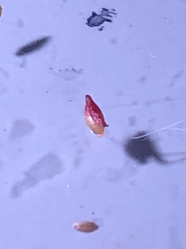
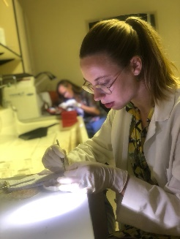
- Katie’s native cover crop seed germination trial is also underway. Currently calculating seed viability for winter varieties.

