Weekly Report 8/16/19
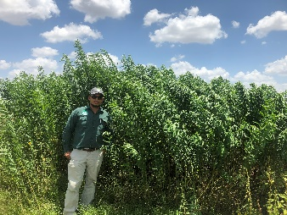
Hilltop
- 8/6 – visited hilltop for conference call & collected weather station data

Dr. Racelis in front of Sunnhemp at hilltop planted in march. Sunnhemp still not flowering!
- Next week:
  - Sunnhemp, cowpea, sudangrass variety seed search – report on Friday (8/23)
  - Order seeds by Monday (8/26)
PPC
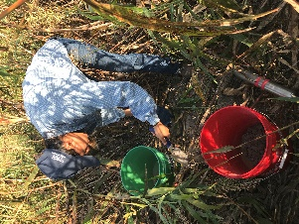
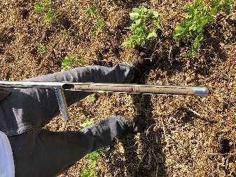
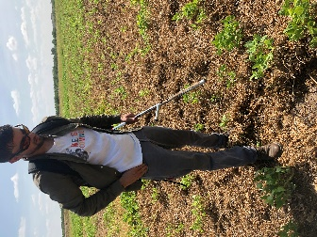
- Field 71
  - Collected soil samples for Dr. Bellow & Anwar on Wednesday (8/14)
    - Can we send samples to TPSL for analysis
- Field 81
  - Collected biomass samples on Wednesday (8/14)
  - Terminated field yesterday (8/15) by roller crimping and flail mowing
    - Aurelio said they will still have to flail mow and disk areas that were roller crimped because they want smaller pieces – will disk as close to planting as possible
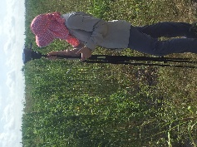
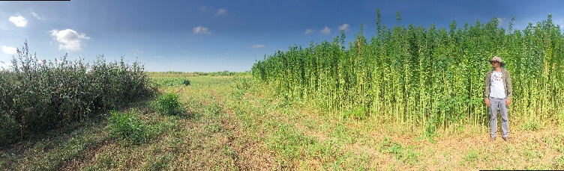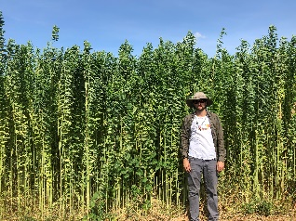
Matt standing by Sunnhemp and Sudangrass in field 71
UTRGV
Attended FARFA 8/11-8/13
- Varietal trial design
  - What data we should collect (qualitiative and quantitative)
